**Table of Contents**



**FPT International School**

--- o0o ---

**PROJECT REPORT**

**<NEXTAG>**

Batch: T2004M

Semester: 1

Group: 1

1. NGUYEN TIEN DAT
2. DUONG XUAN BINH
3. MAI VAN PHAN
4. DAO DUY BACH
5. TRIEU HUY HOANG

**Hanoi - 09/2020**

1. Problem Definition 3

1.1 Overview 3

i. *Introduction* 3

ii. Implementation Environment 4

1.2 User Stories 5

*Customers* 5

a) Search Product 5

b) View Product 5

c) Purchase Product 5

d) Compare Product 5

e) Contact us 5

2. Flowchart 6

2.1 Register 6

2.2 Search Product 7

2.3 Purchase Products 8

3. UI\UX 9

3.1 Register 9

3.2 Homepage 10

3.3 New Arrival 11

3.4 Men 12

3.5 Women 13

3.6 Promotion 14

3.7 Blog 15

3.8 Contact 16

3.9 Compare Product 17

3.10 Shopping Cart 18

3.11 Checkout Product 19

i. Address 19

ii. Delivery Method 20

iii. Payment Method 20

iv. Order Review 21

Summary 22

# Problem Definition

## Overview

### *Introduction*

NEXTAG is selling various types of Purse and Wallets. The company advertises by distributing the pamphlets, advertising on television and so on. Due to rapid development in internet field, the company decides to launch a website where people will get all the information about the various products available with them easily.

The website is to be developed for the Windows Platform using HTML5, JavaScript and Geolocation. The site should work well in all leading browsers including Chrome, IE, Firefox etc.

**Requirement Specification:**

The Web site is to be created based on the following requirements:

1. The Home Page should be created making use of Frames with a suitable logo.
2. Home Page should contain details on Purse and Wallets with suitable images.
3. The site should display a menu which will contain the options for brief introduction about the various purse and wallets available, location of the shop and any other information if required.
4. The information should be categorized according to the brand names of the products like if a User wants to see only “LOUIS VUITTON” products or any other companies products then he/she can click on a Link/button/menu etc and can see only that Brand products.
5. When a user selects any particular brand, a list of products for that brand will be displayed.
6. A brief summary of features of individual products should be displayed on the Web Page along with the product but detailed Features should be stored in Individual Word documents which can be downloaded or viewed by the User who wishes to see the same.
7. The user should also be able to compare the various products of different as well as similar brands.
8. There should be a “Contact Us” page which will have the Address of the Company which is as follows and the mail address which when clicked will invoke the local mail client from where they can send an email. Address of the Company should be displayed using GeoLocation API (eg. GoogleMaps).

### Implementation Environment

* HTML5/ CSS/ JavaScript
* Boostrap / Jquery
* Owl Carousel
* Google Chrome/ Mozilla FireFox/ Internet Explorer
* Methodology: Scrum

## User Stories

### *Customers*

#### Search Product

As a customer, I want to find products to purchase for myself.

#### View Product

#### As a customer, I want to view the details of your product to consider to purchase or not.

#### Purchase Product

#### As a customer, I want to purchase your product, can change quantity of the product, and see the total of my deal.

#### Compare Product

#### As a customer I want to compare products before making a decision to buy something.

#### Contact us

#### As a customer I would like to contact the store by address, phone number, email,…

# Flowchart

## Register

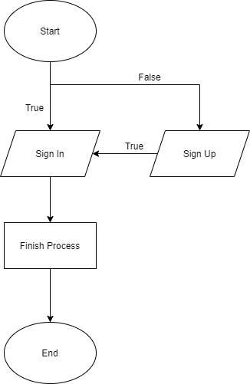

## Search Product

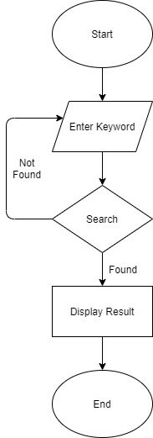

## Purchase Products

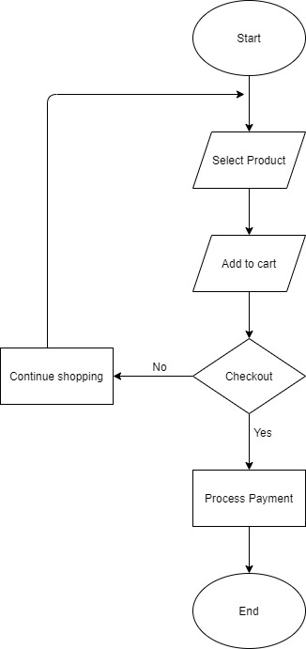

# UI\UX

## Register

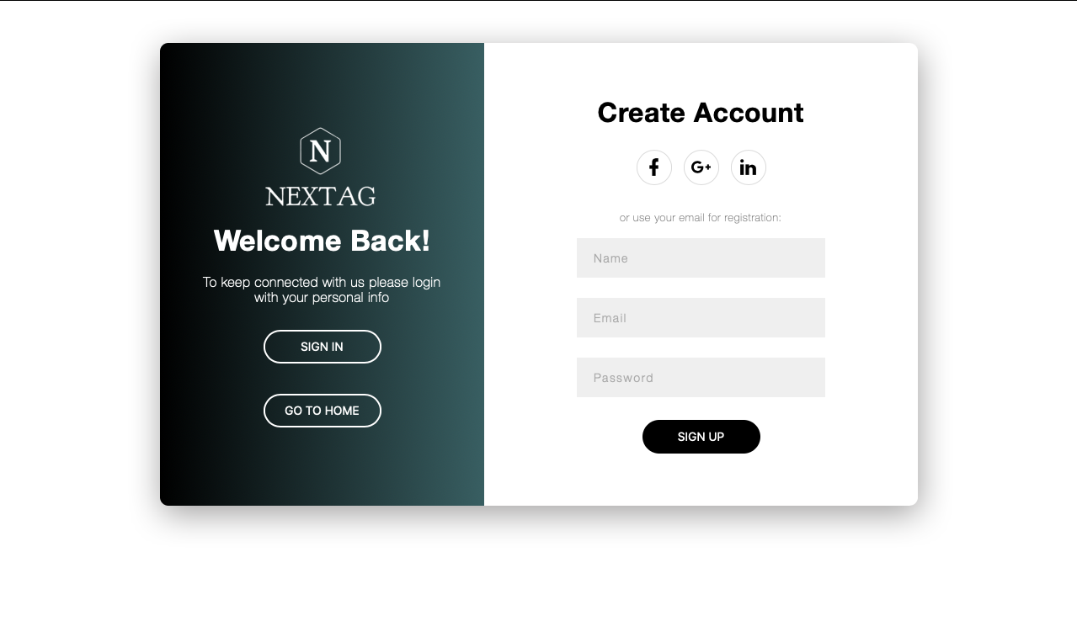

## Homepage

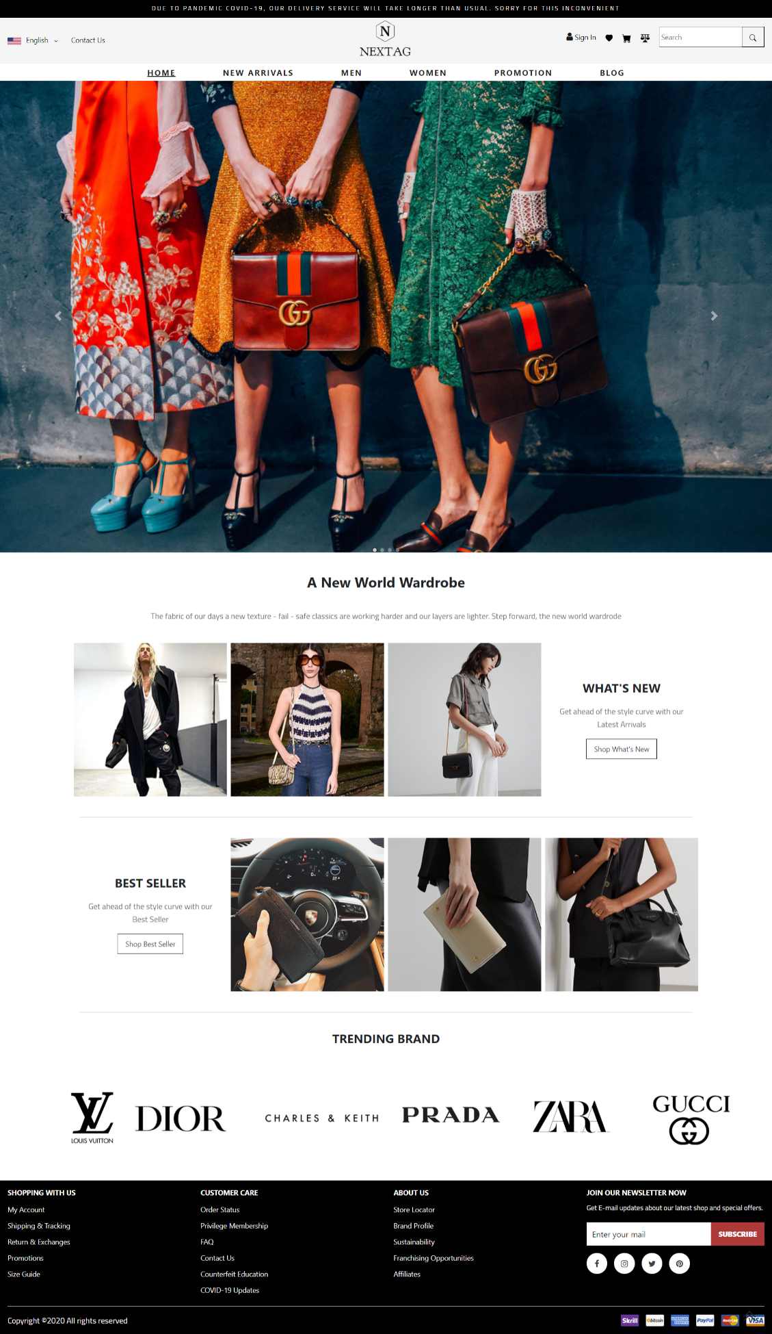

## New Arrival

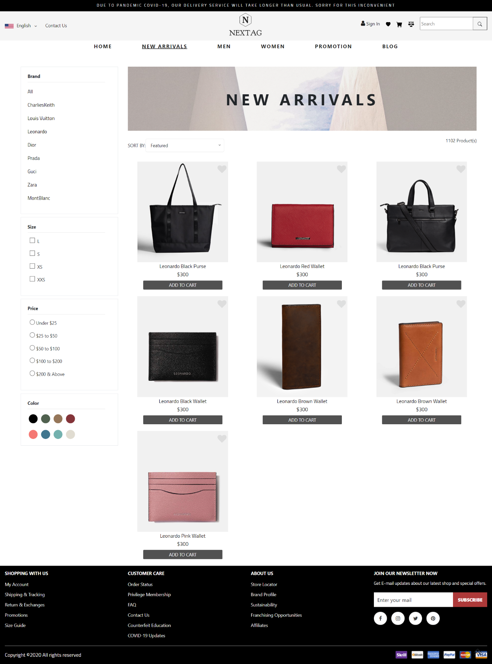

## Men

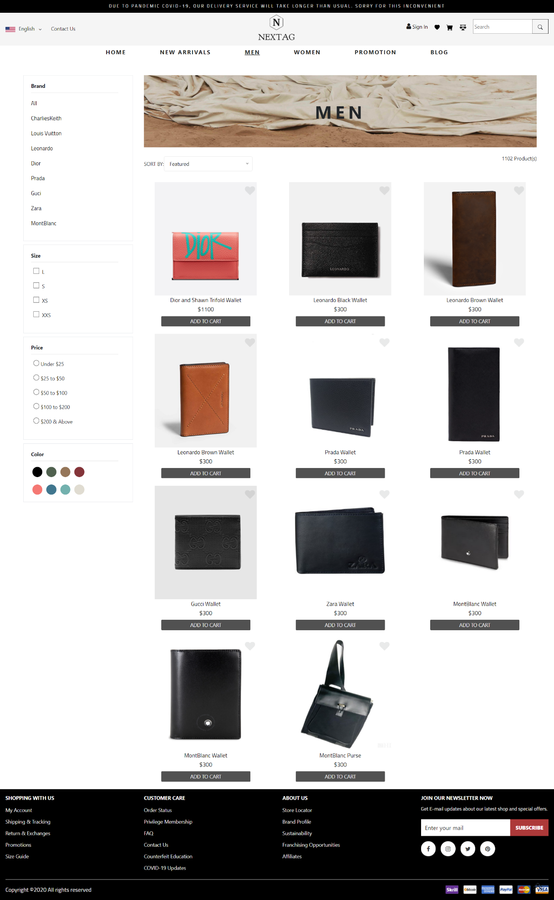

## Women

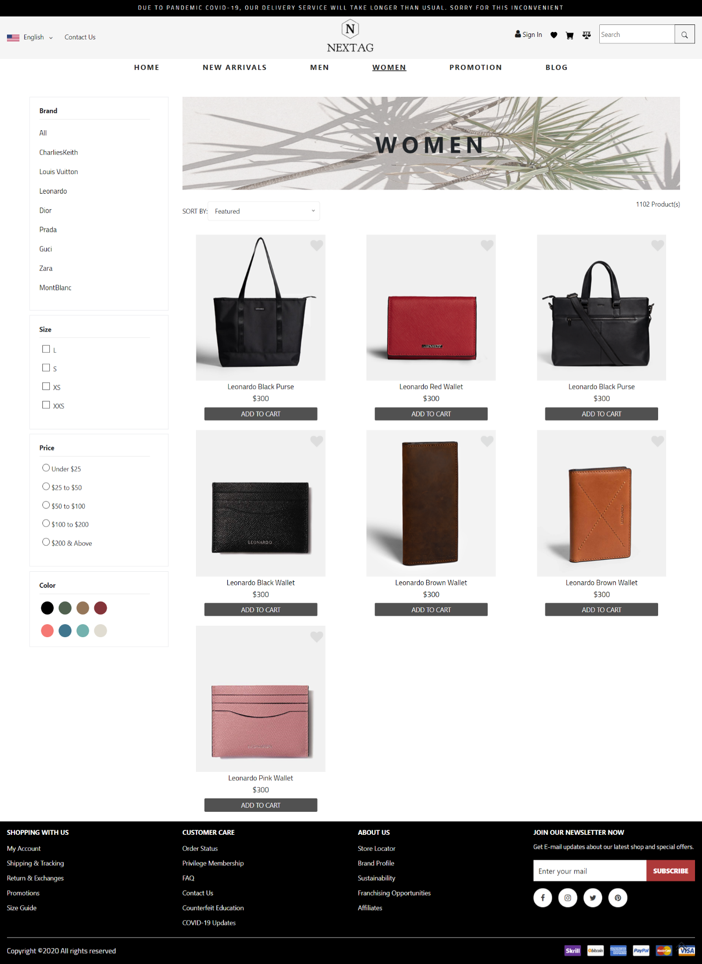

## Promotion

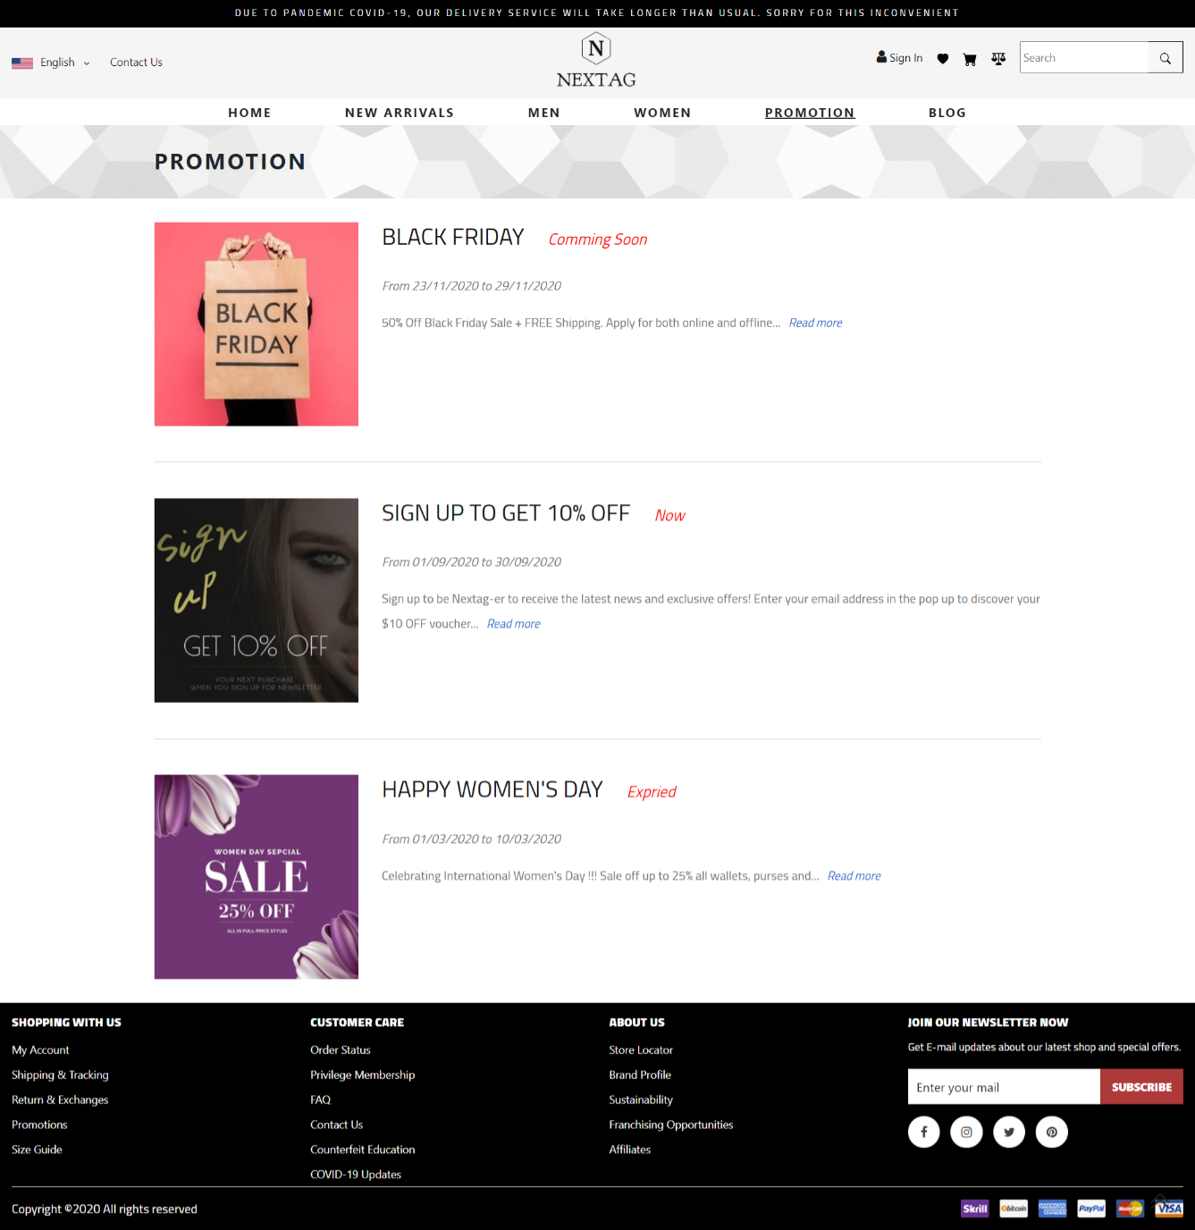

## Blog

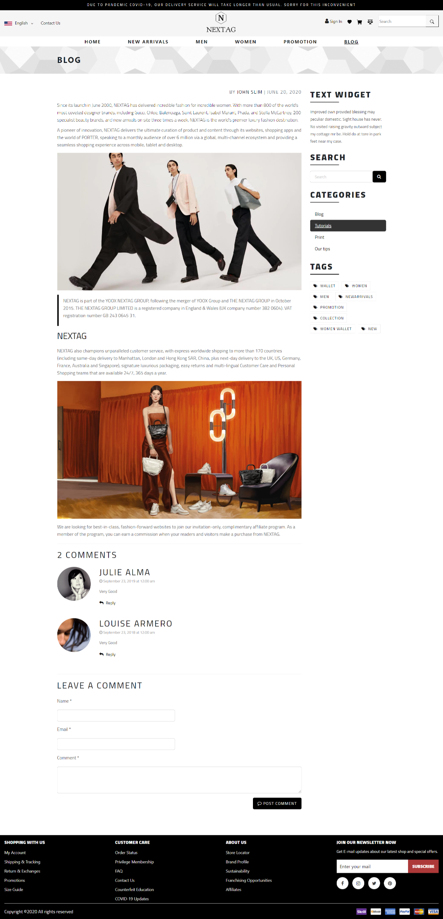

## Contact

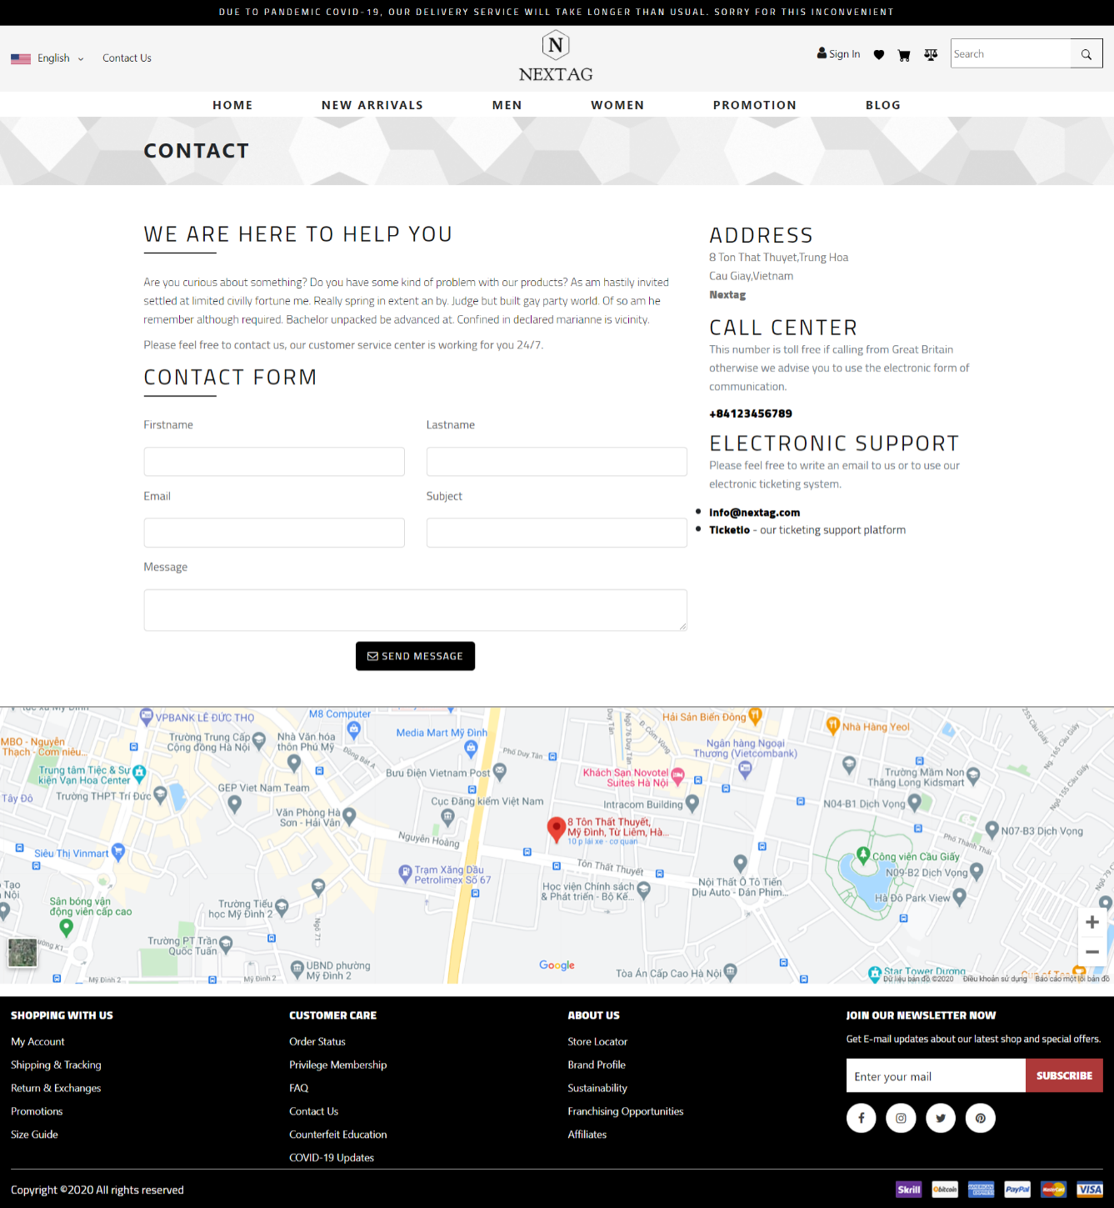

## Compare Product

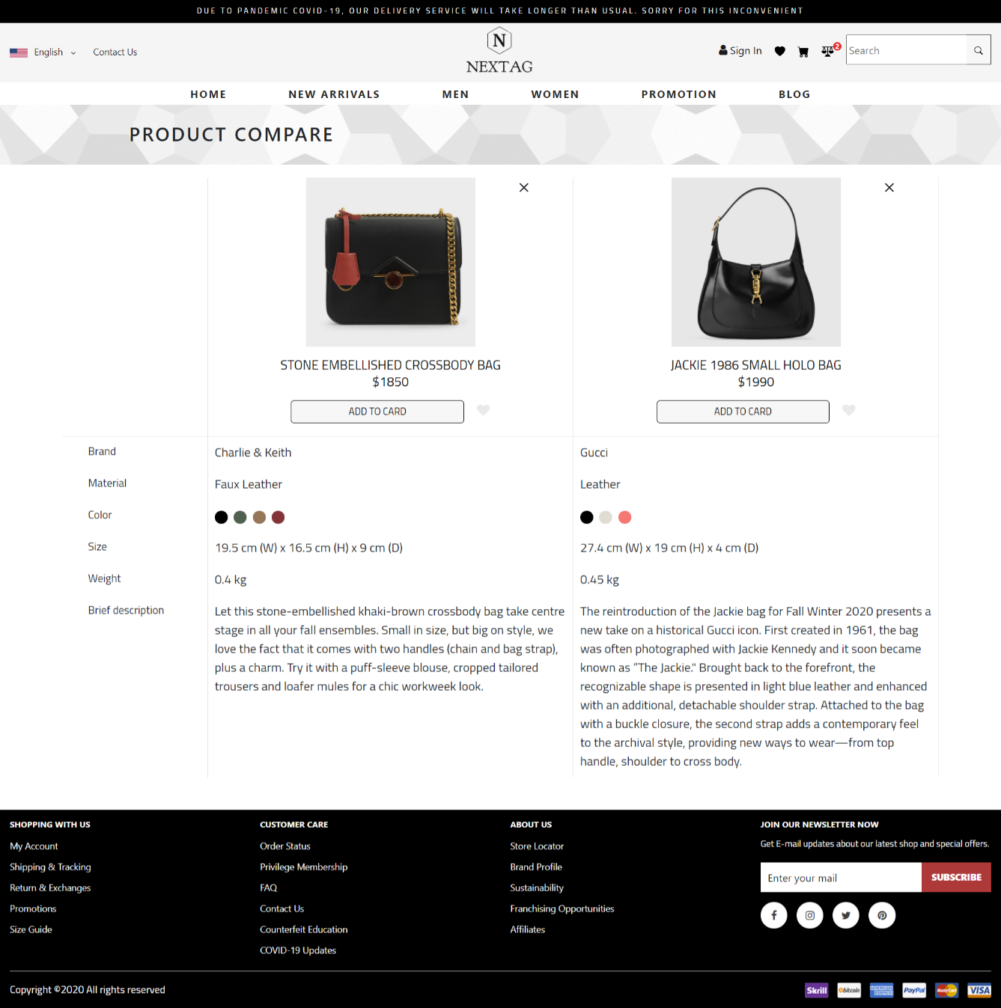

## Shopping Cart

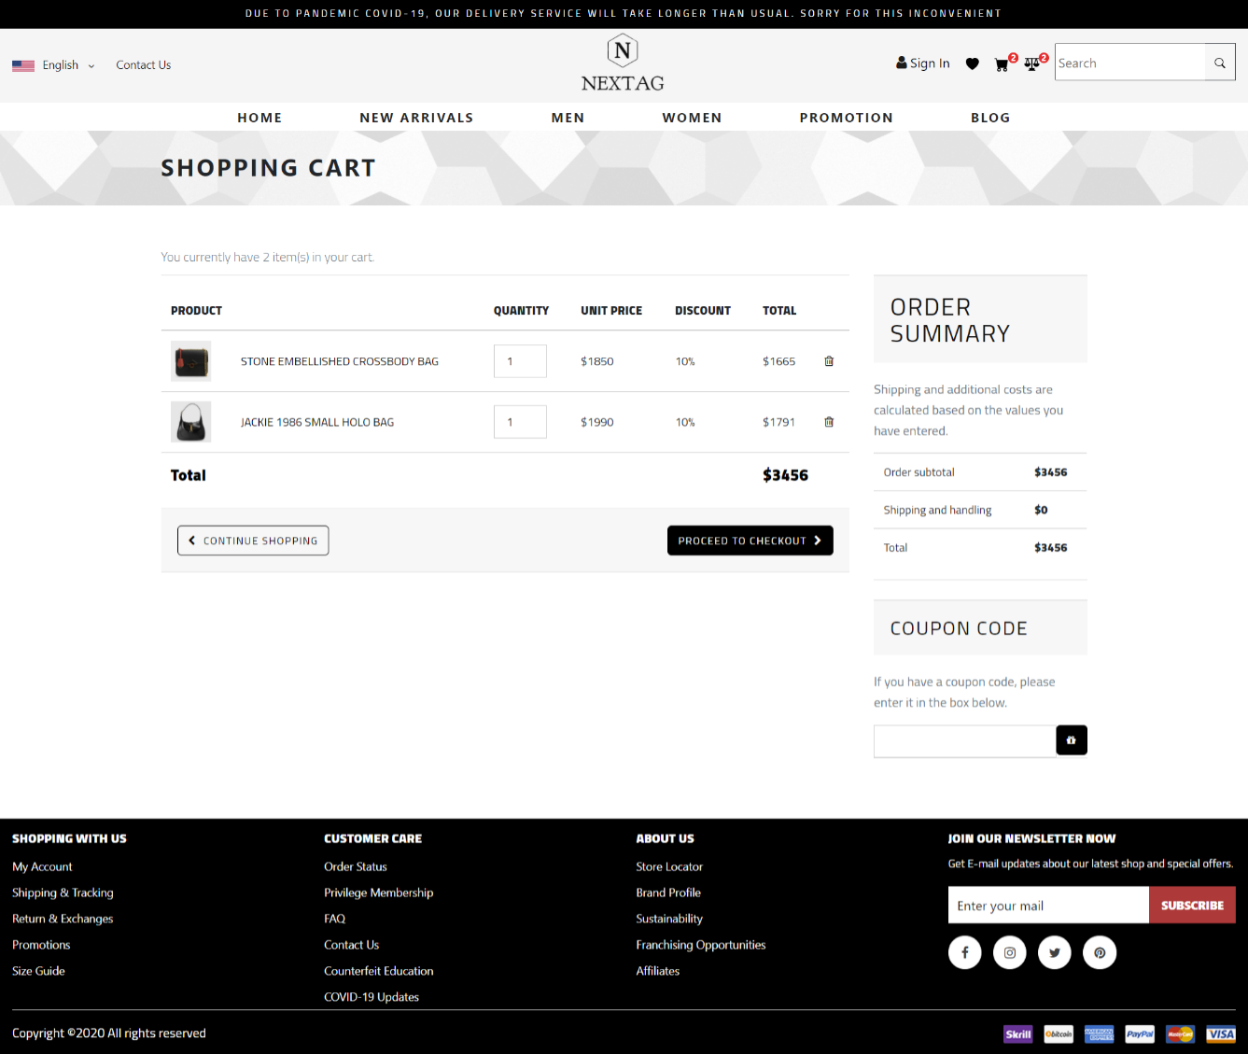

## Checkout Product

### Address

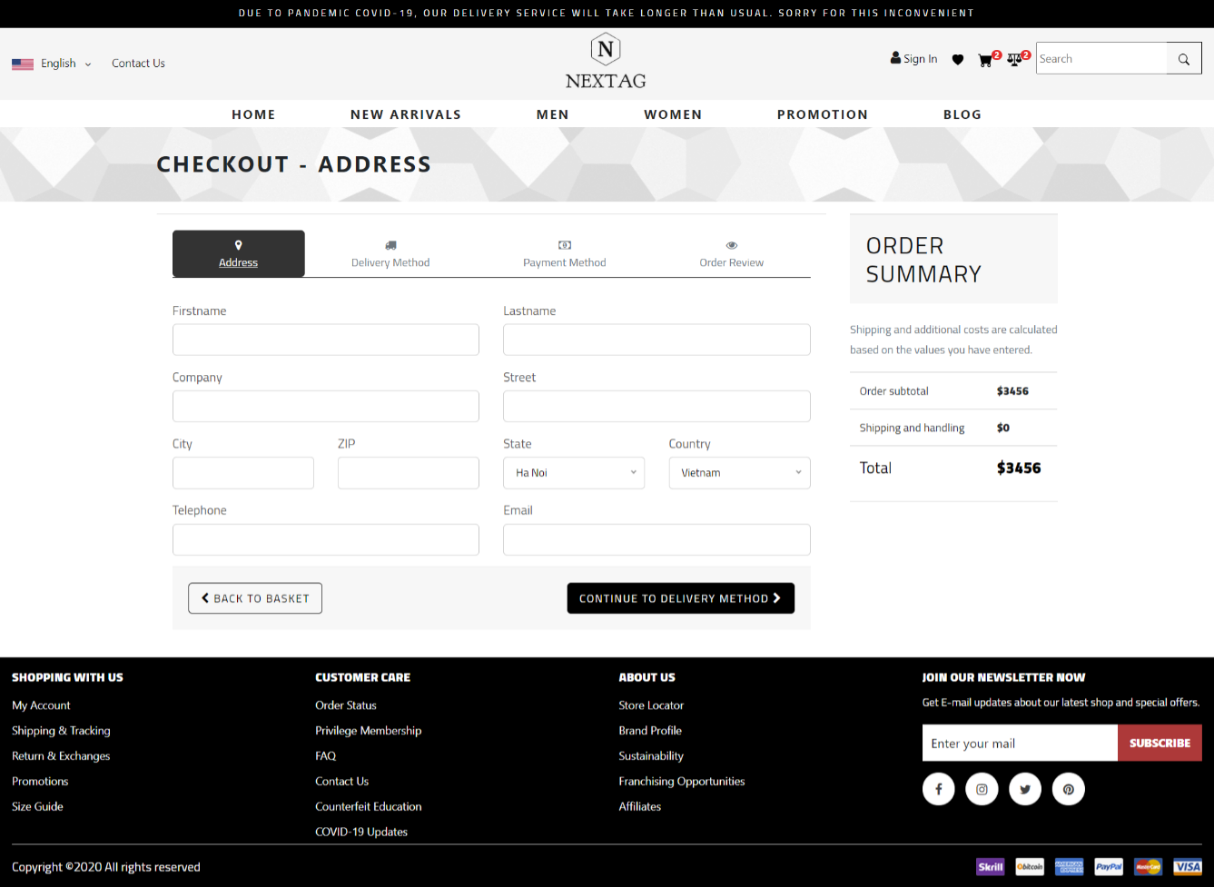

### Delivery Method

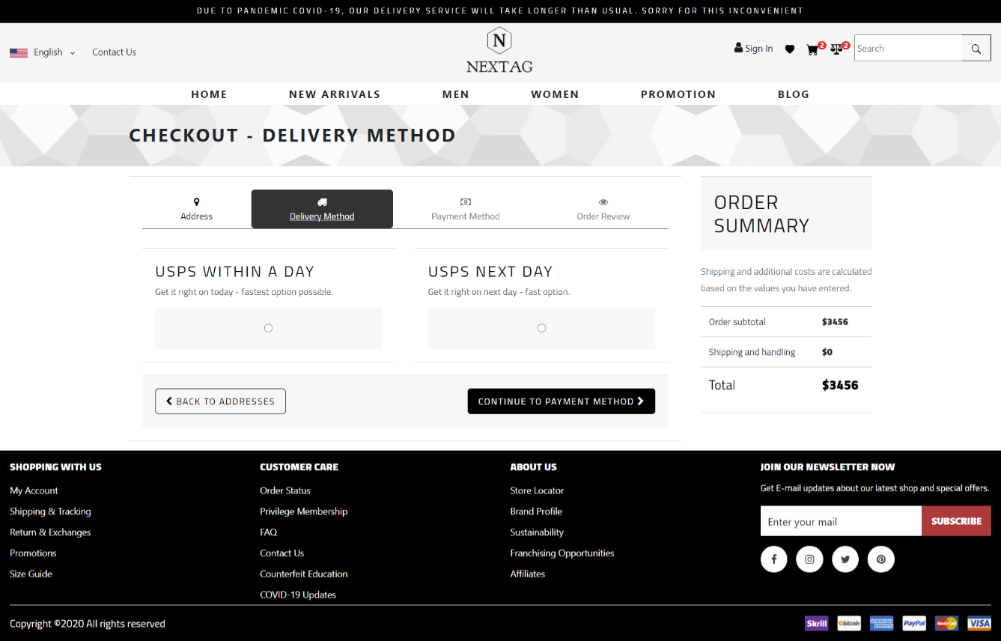

### Payment Method

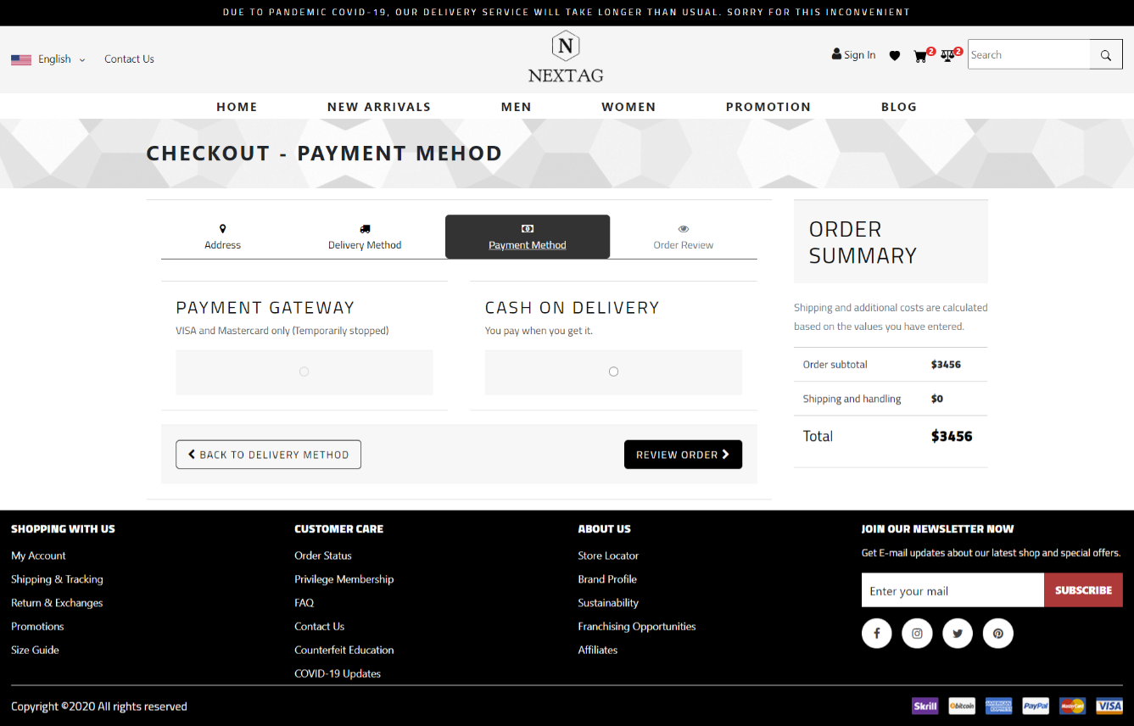

### Order Review

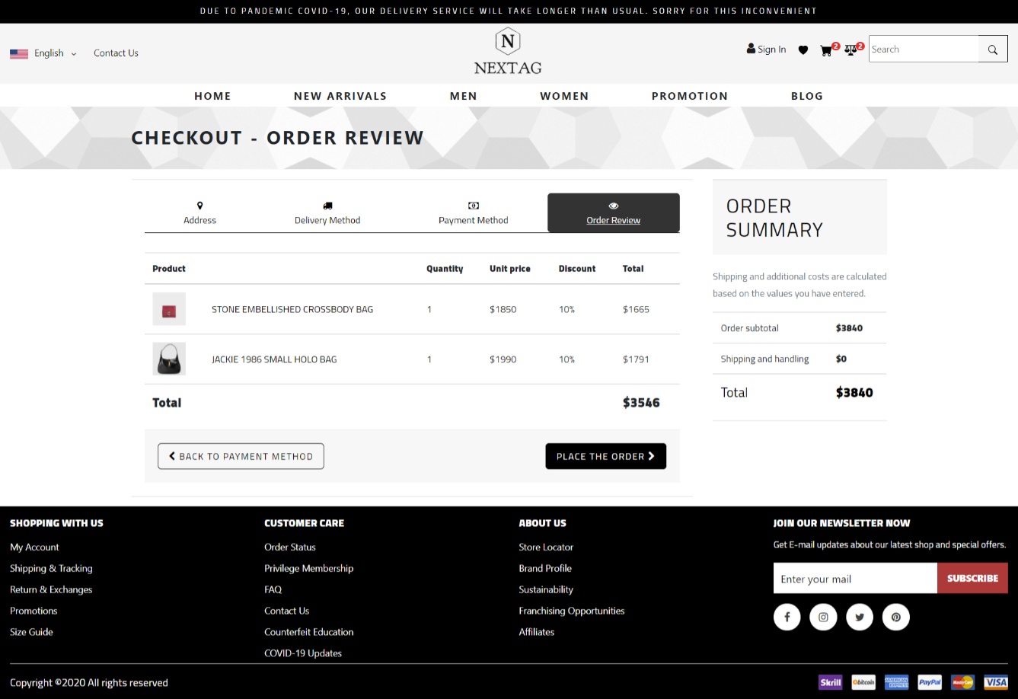

# Summary

|  |  |  |
| --- | --- | --- |
| **ID** | **Responsible** | **Task** |
| TH2002021 | Nguyen Tien Dat | Develep: Homepage, Men page, Women page, New Arrivals page |
| TH2004002 | Duong Xuan Binh | Develop: Product Detail page, Promotion page Support: JS shopping cart, Checkout Collect contents |
| TH2002011 | Mai Van Phan | Develop: Blog page, Shopping cart, Checkout page, Contact page |
| TH2002008 | Dao Duy Bach | Develop: Compare page |
| TH2002018 | Trieu Huy Hoang |  |